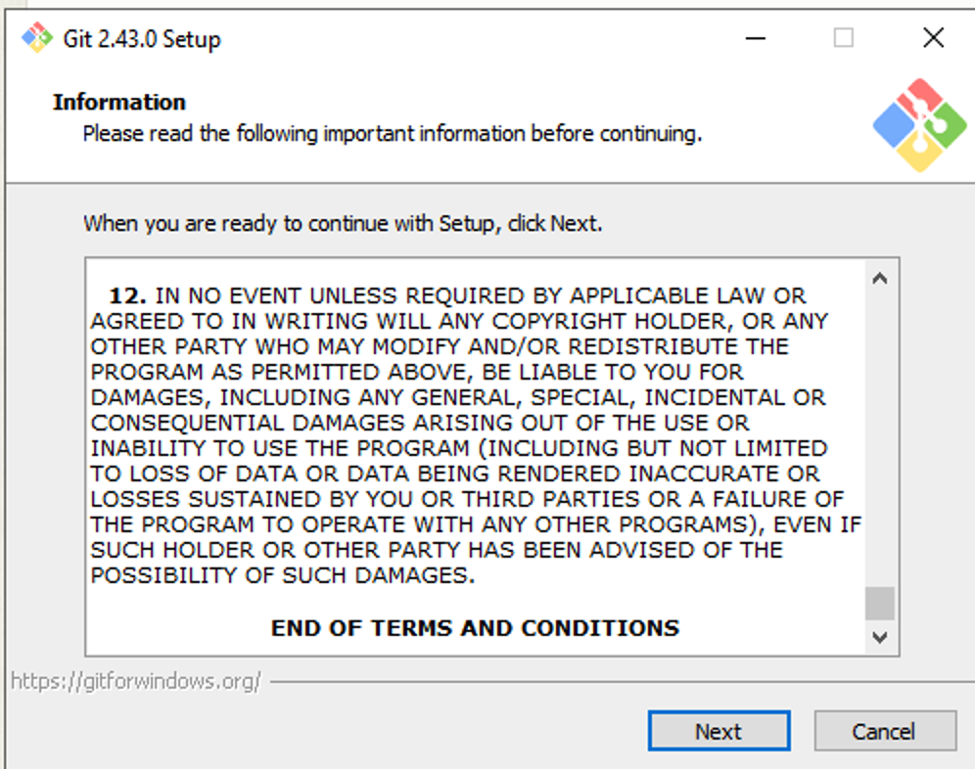

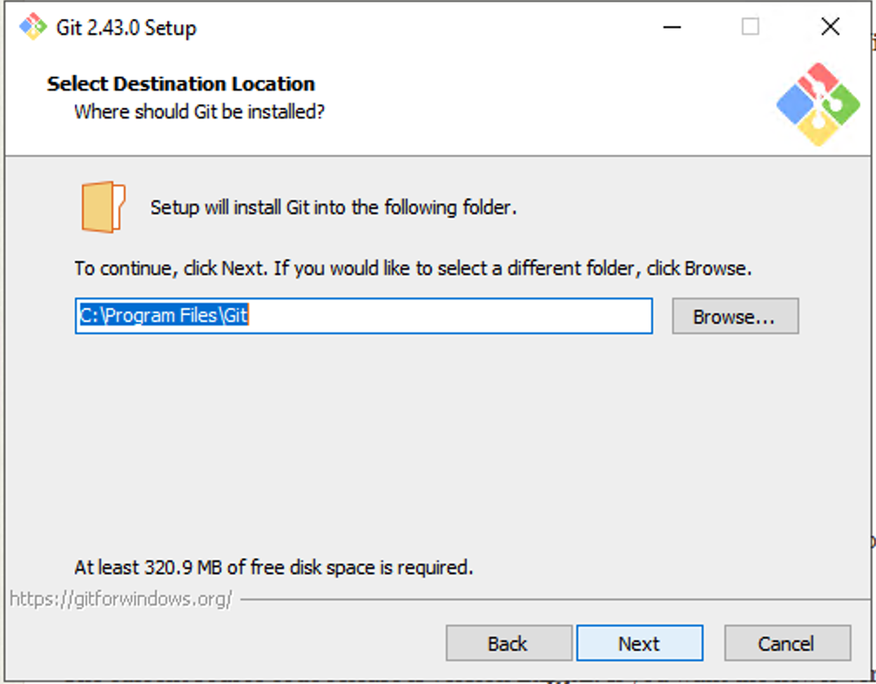

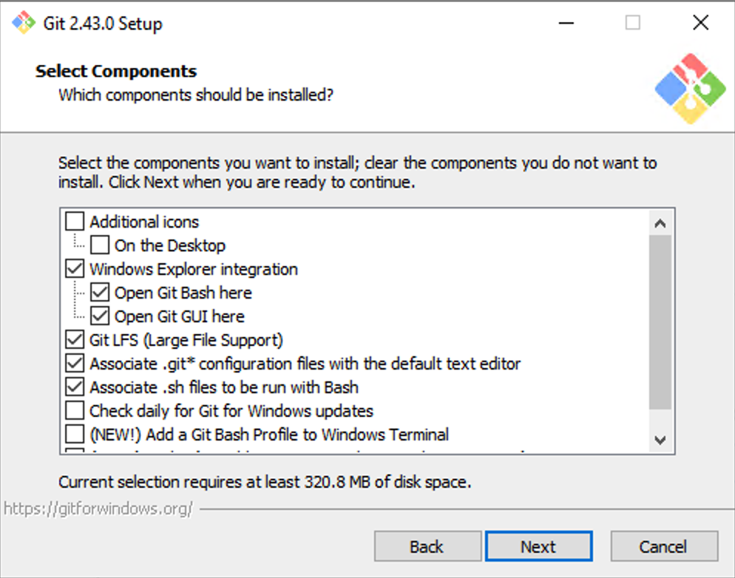

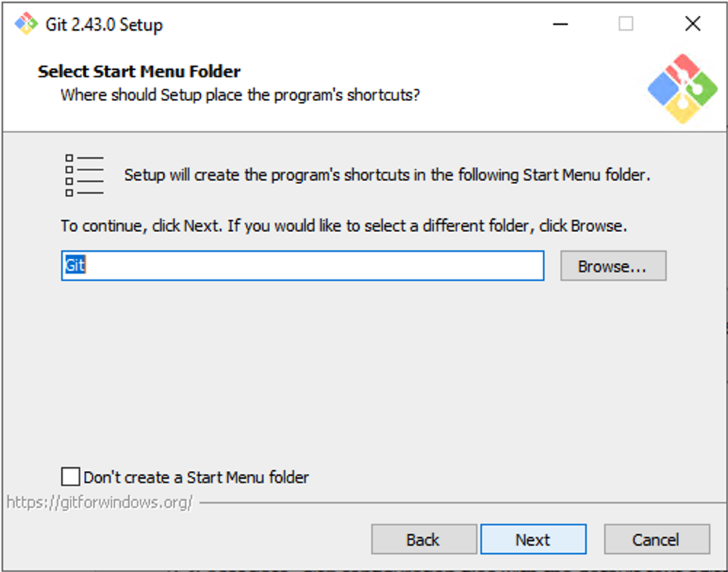

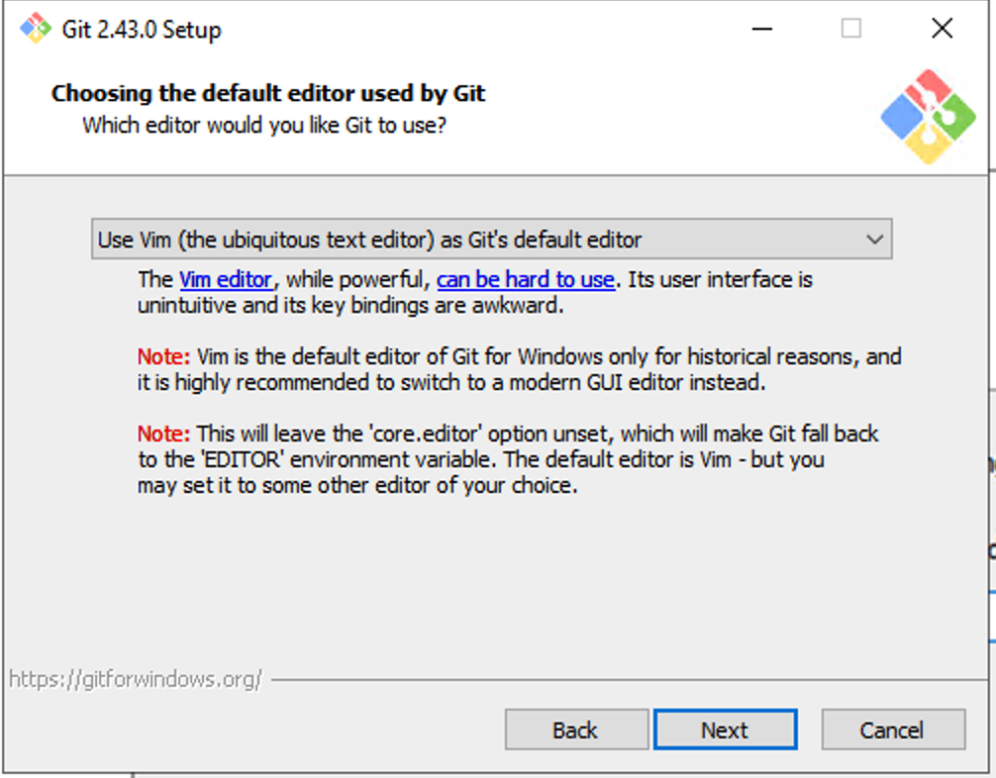

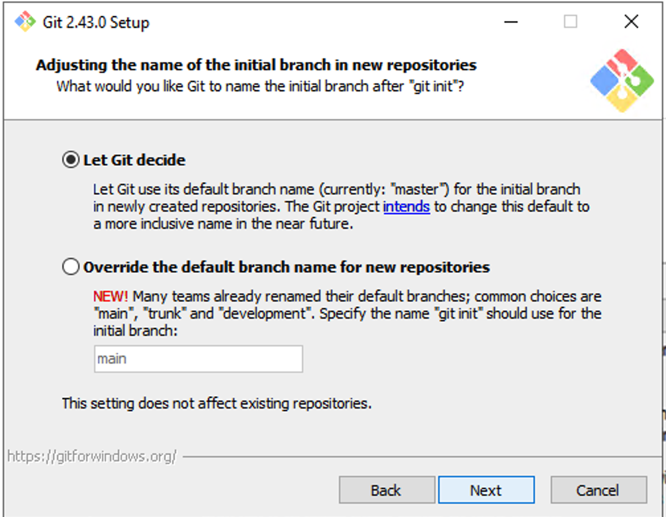

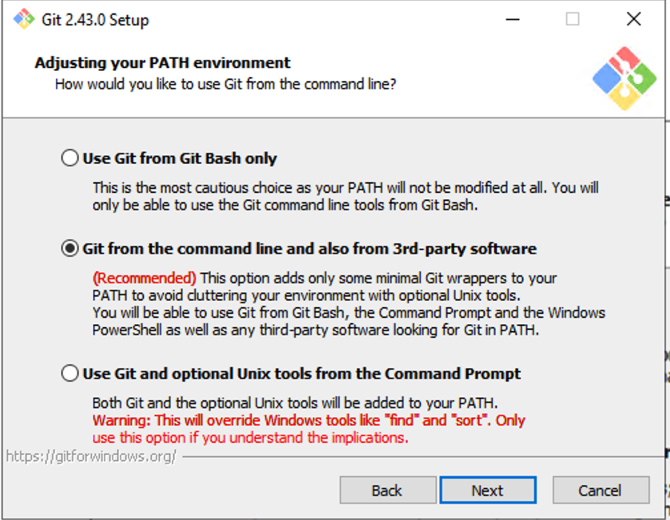

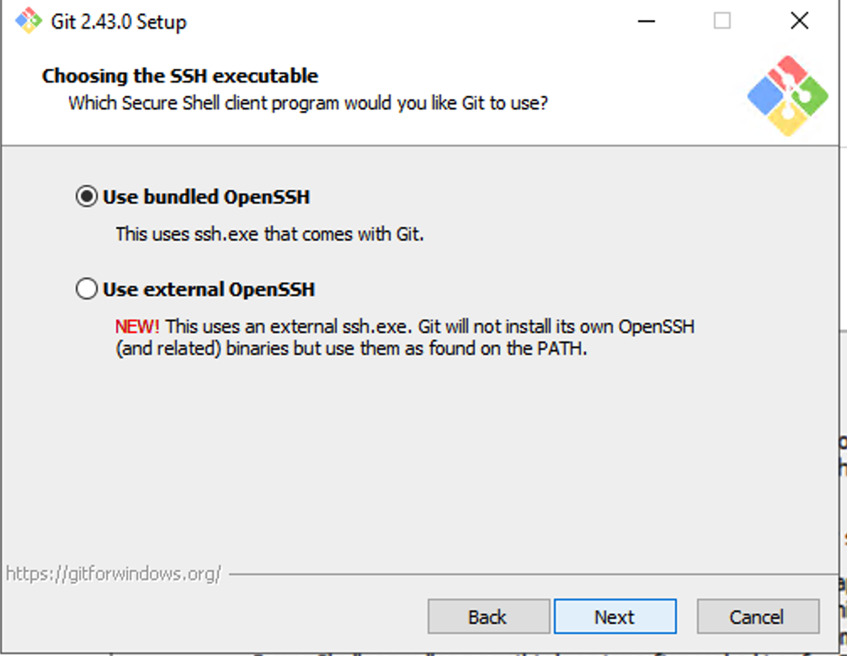

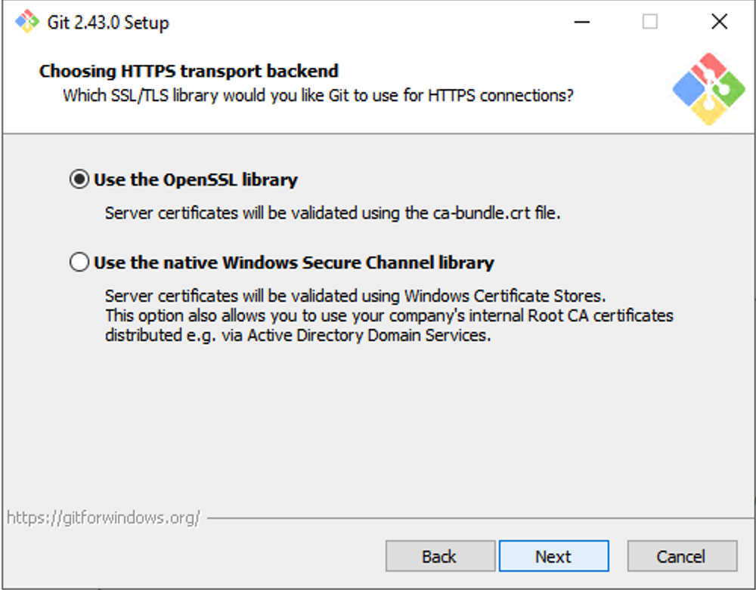

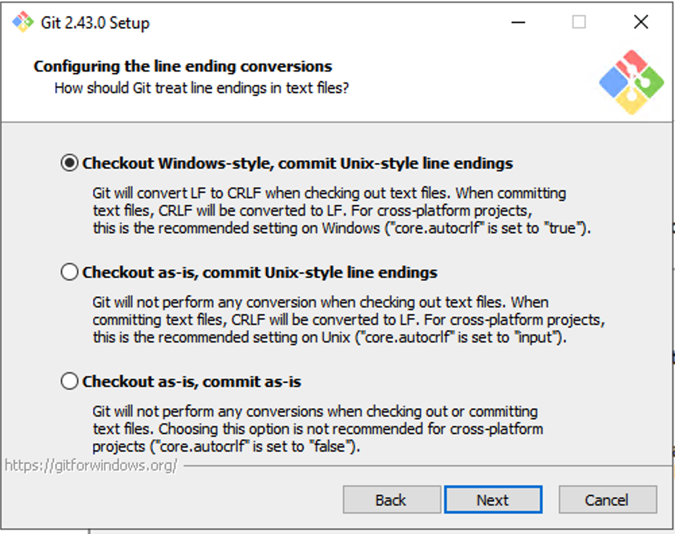

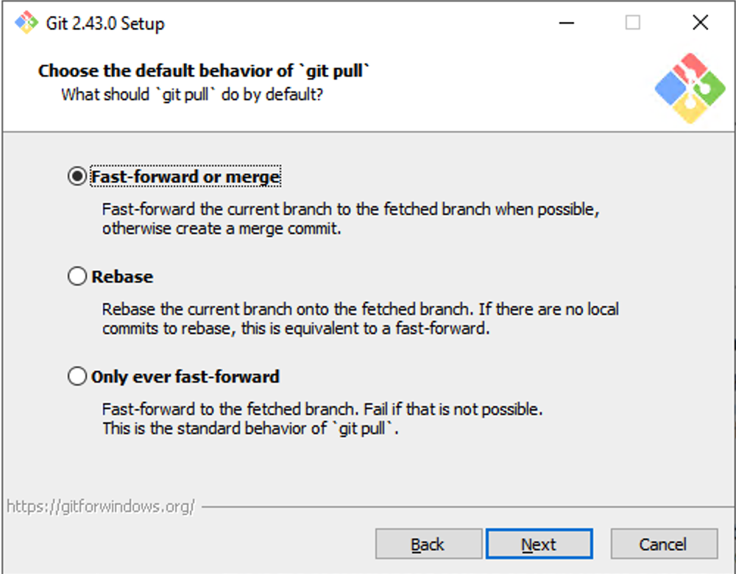

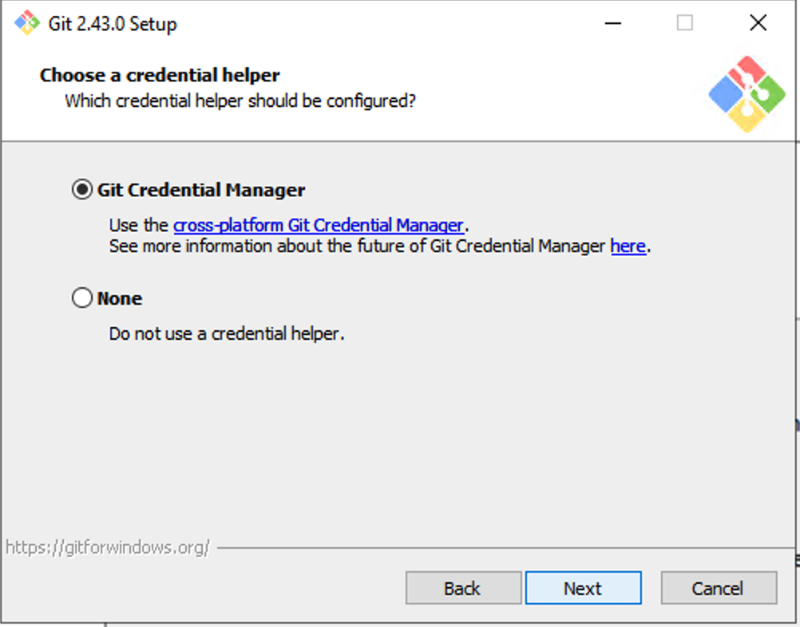

Creating a sas file in your local repository:

jainm09@W11560D356DYS3 MINGW64 /f/Cliniqua/User Folders/Mayuri/WIP/Github/New (main)

$ touch my_sas_code.sas

$ git status

On branch main

Your branch is up to date with 'origin/main'.

Changes not staged for commit:

(use "git add <file>..." to update what will be committed)

(use "git restore <file>..." to discard changes in working directory)

modified: SurvivalAnalysis.sas

Untracked files:

(use "git add <file>..." to include in what will be committed)

my_sas_code.sas

no changes added to commit (use "git add" and/or "git commit -a")

jainm09@W11560D356DYS3 MINGW64 /f/Cliniqua/User Folders/Mayuri/WIP/Github/New (main)

$ git add my_sas_code.sas

jainm09@W11560D356DYS3 MINGW64 /f/Cliniqua/User Folders/Mayuri/WIP/Github/New (main)

$ git commit -m "Add my_sas_code.sas file"